I-frame

🧱 What Is I-frame?
# Source: Chatgpt (GPT‑5 Mini) at [12/14/2025]
I-frames in HDLC (High-Level Data Link Control) are a fundamental concept in synchronous and asynchronous data link layer communication. Let’s break it down step by step.

HDLC Frame Types
# Source: Chatgpt (GPT‑5 Mini) at [12/14/2025]
HDLC frames are used to reliably transmit data over a point-to-point or multipoint link. There are three main types of HDLC frames:
- I-frames (Information frames) – carry user data and control information.
- S-frames (Supervisory frames) – used for flow and error control.
- U-frames (Unnumbered frames) – manage link control (setup, disconnect, mode changes).

What I-frames Do
# Source: Chatgpt (GPT‑5 Mini) at [12/14/2025]
- Carry actual user data (payload) from upper layers.
- Include sequencing information for error detection and reliable delivery.
- Support flow control and acknowledgment through sequence numbers.

Structure of an I-frame
# Source: Chatgpt (GPT‑5 Mini) at [12/14/2025]
An I-frame typically consists of:
- Address field – identifies the destination station.
- Control field – contains:
  - N(S): send sequence number (number of the current frame)
  - N(R): receive sequence number (acknowledgment number)
  - P/F bit: poll/final bit for command/response control
- Information field (Data) – the payload from upper layers
- Frame Check Sequence (FCS) – error-detection code

Example of Control Field in I-frame
# Source: Chatgpt (GPT‑5 Mini) at [12/14/2025]
- N(S) = 5 → This is the 6th frame sent (sequence starts at 0).
- N(R) = 3 → The sender has successfully received frames up to 3 from the other side.
This sequencing ensures that frames are delivered in order and without loss.

Key Features
# Source: Chatgpt (GPT‑5 Mini) at [12/14/2025]
- Reliable delivery: lost frames can be retransmitted.
- In-order delivery: sequence numbers maintain correct order.
- Flow control: prevents sender from overwhelming the receiver.

Comparison
# Source: Chatgpt (GPT‑5 Mini) at [12/14/2025]
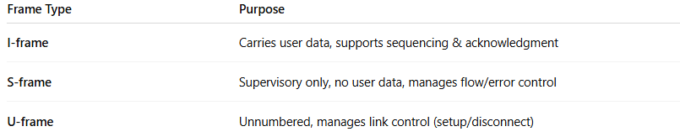
Frame Type | Purpose
I-frame | Carries user data, supports sequencing & acknowledgment
S-frame | Supervisory only, no user data, manages flow/error control
U-frame | Unnumbered, manages link control (setup/disconnect)

In Simple Terms
# Source: Chatgpt (GPT‑5 Mini) at [12/14/2025]
I-frames in HDLC are the “data-carrying trucks” that also report back which trucks were received and in what order, making sure nothing gets lost on the way.

